**LAN:-**

* LAN or Local Area Network connects network devices in such a way that personal computers and workstations can share data, tools, and programs.
* The group of computers and devices are connected together by a switch, or stack of switches, using a private addressing scheme as defined by the TCP/IP protocol.
* Data transmits at a very fast rate as the number of computers linked is limited.
* For example: Home, Office, School etc
* Here is the schematic representation given below

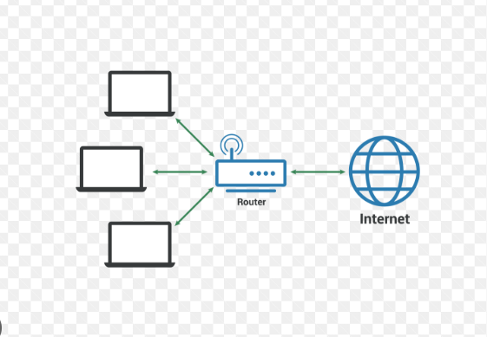

**WAN:-**

* WAN or Wide Area Network is a computer network that extends over a large geographical area, although it might be confined within the bounds of a state or country.
* The technology is high-speed and relatively expensive.
* Covers large geographical areas and can connect remote locations.
* Provides connectivity to the internet.

